CMPE 277

Smartphone Application Development

Lab 1



Submitted to –

Prof. Hungwen Li

on

02/14/2019

by –

Varun Jain

013719108

varun.jain@sjsu.edu

Snapshots

1. Addition

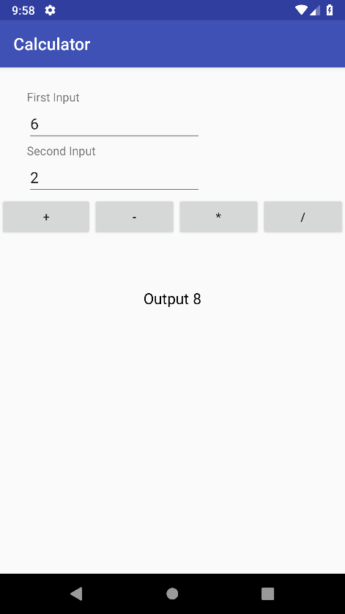

2. Subtraction

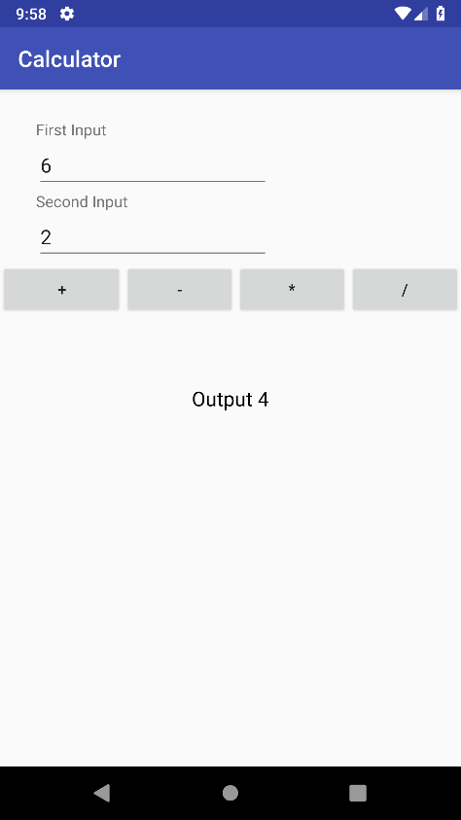

3. Multiplication

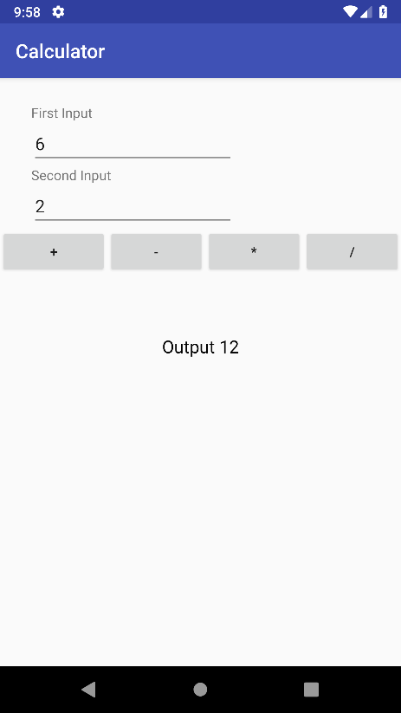

4. Division

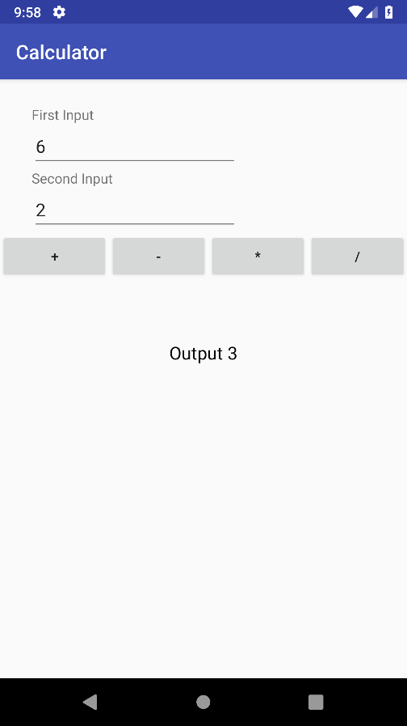

Error Handling

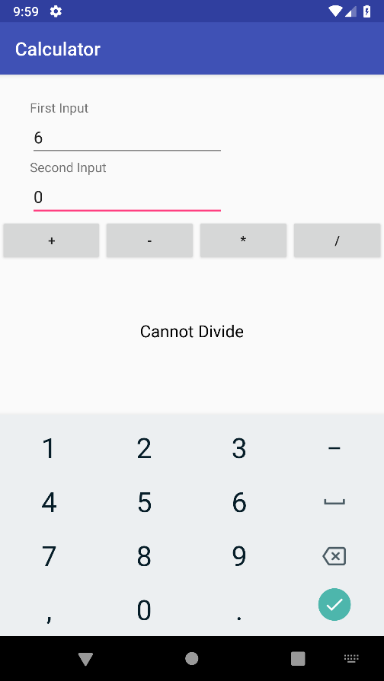

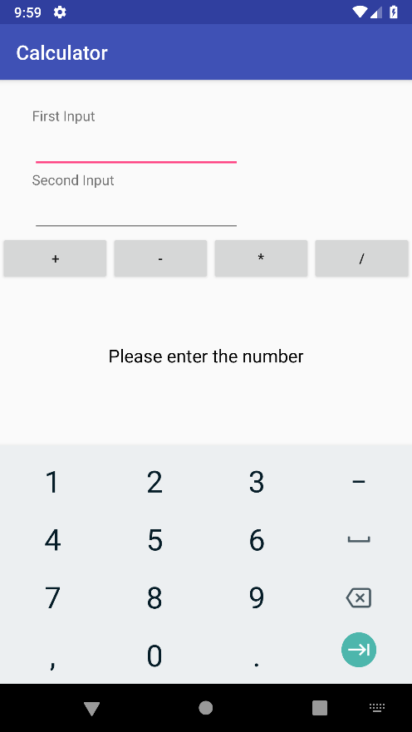

**Questions**

1. What is difference between Gradle and Maven? Why is Gradle used extensively in Android project developments?

Gradle is a development toolbox, which is utilized to deal with the assemble procedure, that permits to characterize the adaptable custom form designs. Each form arrangement can characterize its very own arrangement of code and assets, while reusing the parts basic to all variants of your application. Maven's essential objective is to enable an engineer to grasp the total condition of an improvement exertion in the most limited timeframe. It gives rules to best practices advancement, quality task data, uniform form framework. It enables straight forward movement to new highlights. Gradle gives traditions yet gives the specialist to abrogate them effectively. Gradle construct documents are less verbose as they are written in cool. It gives pleasant DSL to composing assemble undertakings. Has part of good modules and energetic biological community

2. What is project structure in Android Studio? List down the folder structure created for your application.

A project structure defines the work area for an application, like source code and assets, to test code and build configurations.

Whenever a project is created, Android Studio constructs the folder structure to arrange your files. In app folder there are mainly 3 modules

Within each Android app module, files are shown in the following groups:

**Manifests -** Contains the AndroidManifest.xml file.

**Java -**Store the Java source code files, package names, JUnit test code.

**Res -** Contains all non-code resources, such as XML layouts, UI strings, and bitmap images, divided into corresponding sub-directories.

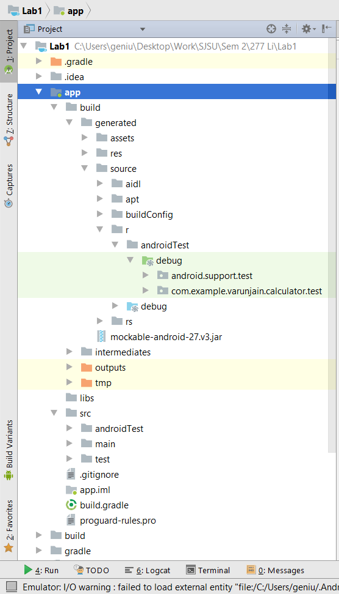

3. What is “adb” and where is it located? What is the importance of “adb”?

ADB or Android Debug Bridge is a command line tool which is used to communicate with any device that can run Android OS. Device can be anything from smart phone, tablet, smart TV, smartwatch. ADB is beneficial to extend developer scope by installing app from out side of play store, deploying their own applications to test and debug them, accessing hidden developer specific features.

However, ADB cannot be found in Android Studio, it is actually located in Android SDK Platform-Tools package.

As name suggests ADB is important to fill the bridge between the developer and the phone. ADB is used to run the commands directly on the android phone. ADB is made up of mainly 3 components. Firstly, a client which is your computer which sends a command from terminal to your phone device. Secondly, a daemon, which is a service that runs on both the end, computer as well as the phone and runs the command on later part. Lastly, a server which is a software that actually execute the commands from the client.

4. Use “Android Monitor” for your application and attach screenshots of your application graphs from Android Monitor, in report.

